**AI in Manufacturing: Real-World Impact and Future Possibilities  
Oluchi Obinna  
6252-ITAI-2372-Artificial Intel Applications**

### 

### 

### 

### 

### 

### 

### 

### **Introduction: The Role of AI in Manufacturing**

Artificial Intelligence is changing the way things are made in the manufacturing world. In the past, factories depended mostly on human workers and basic machines to produce goods. But today, AI is being used to improve almost every part of the process- spanning from creating products on the assembly line to managing the supply of materials. This works by using AI programs to study large amounts of data, learn from it, and then make smart decisions without needing constant human input. This technology helps save time, reduce mistakes, and increase the overall quality of products.

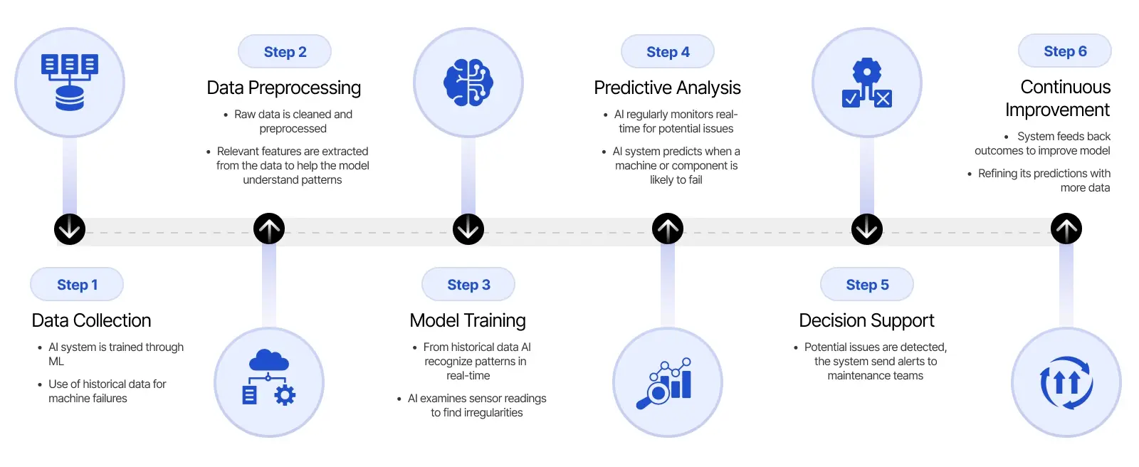[Important-Steps-to-Implement-AI-For-Predictive-Maintenance.webp](https://markovate.com/wp-content/uploads/2024/09/Important-Steps-to-Implement-AI-For-Predictive-Maintenance.webp)

One of the biggest problems manufacturers face is unexpected machine failures. When a machine suddenly stops working, it can bring the entire production process to a halt, costing companies time and money. Additionally, rising costs and the pressure to deliver high-quality goods quickly make it harder for companies to stay competitive. AI helps solve these issues by introducing tools like predictive maintenance, which can alert workers before a machine breaks. Other AI applications include using robots to do repetitive tasks and using AI cameras to check the quality of products during production.

This report explores how AI is already making a big difference in the real world. It looks at a case study from General Electric (GE), a company that uses AI to predict when machines might fail so they can be fixed early. This helps prevent delays and saves money. The report also presents a new idea—using AI to reduce waste during the manufacturing process. This proposal shows how AI can help factories not only work faster but also become more environmentally friendly and cost-effective. Through these examples, the report highlights the powerful impact AI can have on modern manufacturing.

### 

### 

### **Case Study Analysis: Predictive Maintenance at General Electric (GE)**

#### **The Challenge**

#### In large manufacturing factories, machines are used to build and assemble products every day. These machines are usually very advanced, but they can still break down without warning. When a machine stops working suddenly, it can bring the entire production line to a stop. This means that no products can be made until the machine is fixed, which wastes a lot of time and money. For companies like General Electric (GE), even a short delay in production can cost millions of dollars, especially when working with important industries like aviation, energy, or healthcare. These unexpected problems also create safety risks for workers and increase stress for maintenance teams.

#### To solve this issue, GE wanted to find a way to stop breakdowns before they even happened. They faced the challenge of figuring out how to predict when a machine might fail, instead of waiting for something to go wrong. This wasn’t easy because machines produce large amounts of data every second- like temperature, vibration, and speed- and it’s hard for humans to keep track of it all. GE needed a smart system that could watch all this data, understand patterns, and send warnings before a machine broke down. Their goal was to fix small problems early so they wouldn't turn into bigger ones, saving time, money, and keeping everything running smoothly.

#### **The AI Solution**

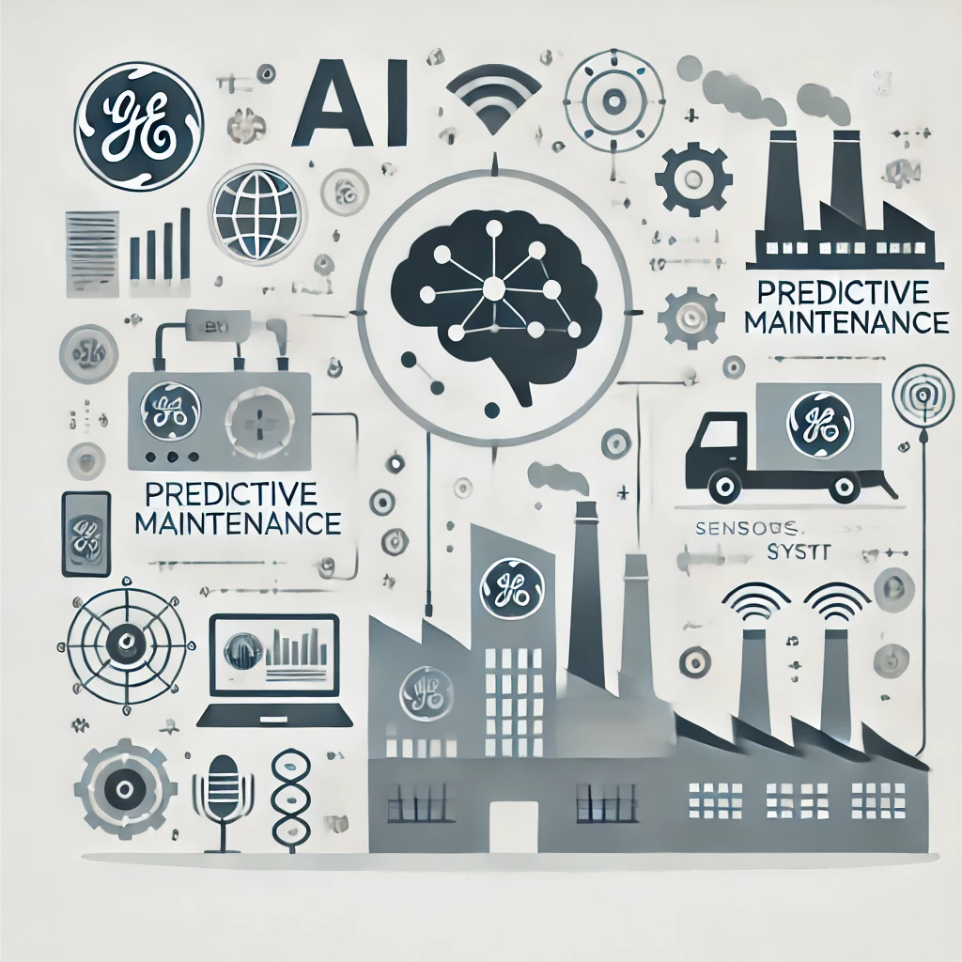

[*How-GE-Uses-AI-to-Implement-Predictive-Maintenance-in-Its-Manufacturing-Plants.webp*](https://redresscompliance.com/wp-content/uploads/2025/01/How-GE-Uses-AI-to-Implement-Predictive-Maintenance-in-Its-Manufacturing-Plants.webp)

To solve the problem of unexpected machine failures, GE started using a system called **AI-powered predictive maintenance**. This system uses artificial intelligence to study data collected from machines while they are working. For example, machines give off signals such as heat (temperature), how much they shake (vibration), and how much energy they use. By collecting this information through sensors, the AI system can look for unusual patterns that might mean a machine is starting to have a problem. Instead of waiting for a machine to break down, the system warns workers ahead of time, so they can fix it before it gets worse.

This process is kind of like how a doctor checks your heart rate and temperature to see if you're getting sick. In the same way, the AI system checks the “health” of machines. GE also uses a special software platform called **Predix**, which helps organize all the machine data and makes it easier for the AI to understand. With predictive maintenance, GE doesn’t just react to problems- they prevent them. This means their machines last longer, work better, and save the company a lot of money by avoiding surprise breakdowns. It also keeps workers safe and makes the whole production process more efficient.

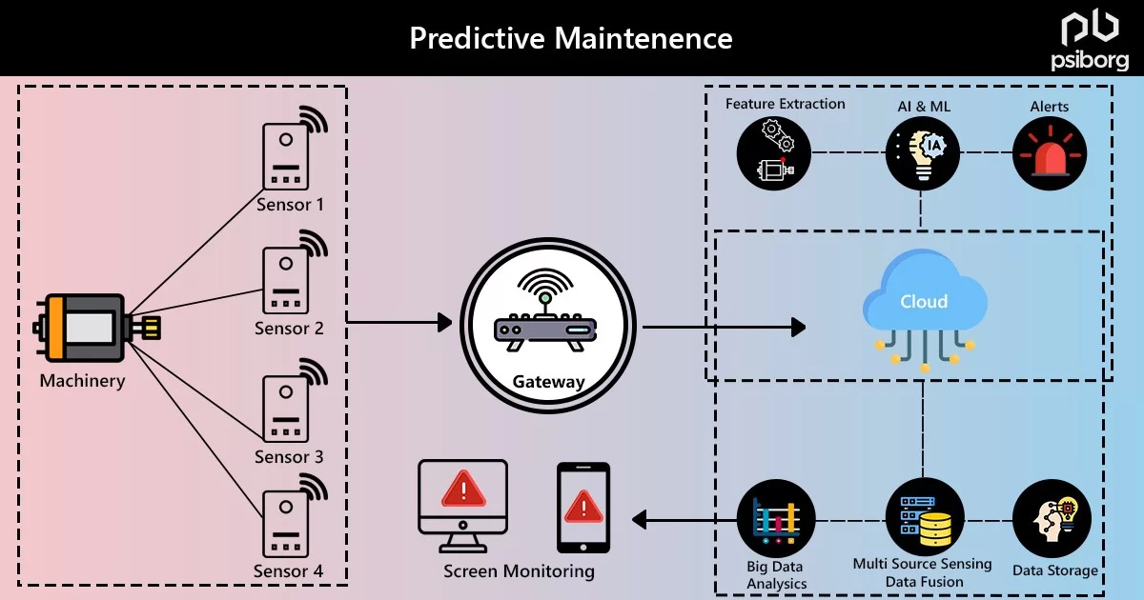

[Predictive-Maintenance-Fb.webp](https://smartdev.com/wp-content/uploads/2024/09/Predictive-Maintenance-Fb.webp)

##### **Technologies Used:**

* **Machine Learning Algorithms**: These analyze large amounts of data from sensors.
* **Industrial Internet of Things (IIoT)**: Sensors installed on machines collect real-time data.
* **Predix Platform**: GE's cloud-based software platform for industrial data.

#### **Outcomes and Benefits**

GE achieved the following results:

| **Benefit** | **Impact** |
| --- | --- |
| Fewer Breakdowns | Machine downtime reduced by 30% |
| Cost Savings | Maintenance costs dropped by $12 billion |
| Improved Efficiency | Machines operated longer without issues |
| Better Safety | Workers were less exposed to sudden failures |

#### **Challenges and Risks**

While the AI solution worked well, GE faced some difficulties:

* **High Initial Costs**: Installing sensors and software was expensive.
* **Data Management**: It was hard to organize and analyze large amounts of data.
* **Training Needs**: Workers had to learn how to use new technology.

Despite these challenges, the benefits of how predictive maintenance works made it a success.

### **Proposal for Innovation: AI for Waste Reduction in Manufacturing**

#### **The Problem**

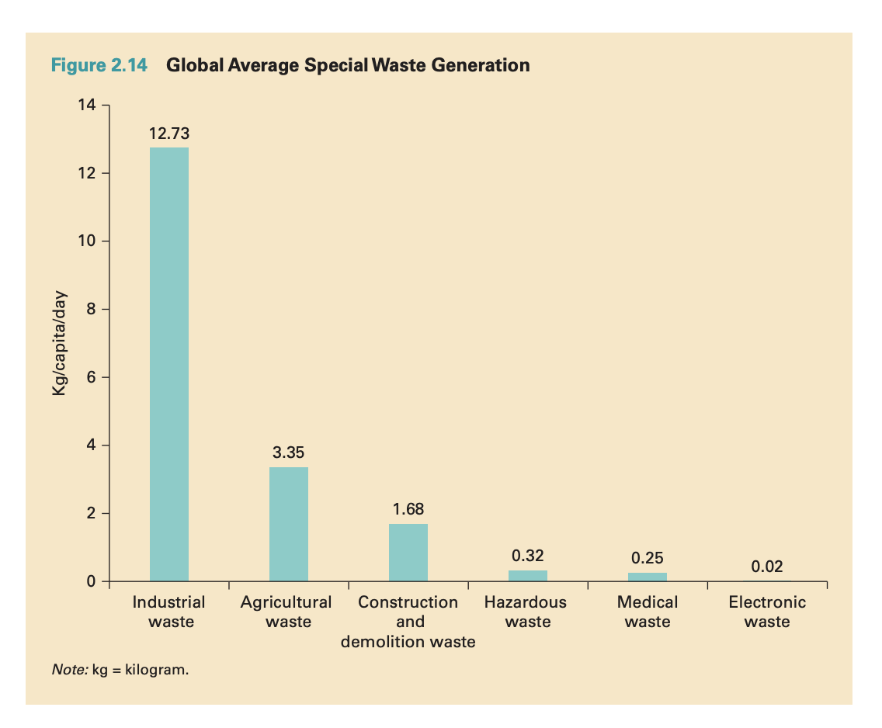

[0Xgn5TzT6IphAozjHnJ2EFV6naRZKTkBtb5FmAuDM4w.png](https://assets.weforum.org/editor/0Xgn5TzT6IphAozjHnJ2EFV6naRZKTkBtb5FmAuDM4w.png)

In many factories, a lot of waste is created during the production process. This waste can come in many forms, like leftover pieces of metal or plastic (called scrap materials), energy that gets used but doesn’t actually help make anything, and products that are made incorrectly and can’t be sold (called defective products). All of this waste adds up quickly and becomes a big problem. Not only does it mean that factories are using more resources than they need, but it also leads to higher costs. When companies have to throw away materials or redo products, they spend more money and time than necessary.

This kind of waste also has a negative impact on the environment. Scrap materials often end up in landfills, and wasted energy can increase pollution, especially if it comes from non-renewable sources like coal or gas. As the world becomes more focused on protecting the planet, companies are under pressure to find better ways to reduce waste. Using fewer materials and producing less pollution doesn’t just help the earth—it also helps companies save money and become more efficient. That’s why many people believe that using smart technologies, like artificial intelligence, could be the key to solving this problem in the future.

#### **Proposed AI Solution: Smart Waste Reduction System**

Proposing an AI system designed to help reduce waste in manufacturing by using smart technology like sensors, cameras, and machine learning. Sensors and cameras would be placed around the factory to constantly monitor the production process in real time. These tools would collect data on how materials are used, how machines are running, and whether products are being made correctly. The machine learning part of the system would study this data and learn to recognize patterns that lead to waste- like when too much material is used or when a machine makes the same mistake over and over. Once the system notices a problem, it could alert workers or even adjust the machines automatically to fix the issue right away. This would help factories use materials more wisely, reduce the number of defective products, and cut down on wasted energy, making the whole process cleaner, smarter, and more cost-effective.

In short, we could:

* Monitor production processes in real-time.
* Detect errors that cause waste.
* Adjust machine settings automatically to reduce defects.

#### **How It Works**

1. **Data Collection**: Sensors and cameras collect data from the production line.
2. **AI Analysis**: Machine learning identifies patterns that lead to waste.
3. **Real-Time Action**: The system gives alerts or adjusts settings automatically.

#### **Benefits of the Proposed System**

| **Benefit** | **Explanation** |
| --- | --- |
| Less Material Waste | Detects and fixes errors early |
| Lower cost | Saves money by using fewer raw materials |
| Greener manufacturing | Reduces environmental impact |
| Improved product quality | Ensures more consistent, higher-quality items |

#### **Challenges to Expect**

* **High Setup Cost**: Installing sensors and training AI models can be expensive.
* **Data Accuracy**: The AI system needs a lot of accurate data to work properly.
* **Worker Training**: Employees need to learn how to use the new system.

Moreover, the long-term benefits make this a smart investment for manufacturers.

### **Conclusion**

### Artificial Intelligence is already having a huge impact on the manufacturing industry. In the case study we explored, General Electric (GE) used AI to predict when machines might fail. By using data like temperature and vibration, GE was able to fix machines before they broke down. This helped them avoid costly delays and save billions of dollars. It also improved safety and allowed production to run more smoothly. This real-life example shows how powerful AI can be when it’s used to solve big problems in factories.

Looking into the future, AI has the potential to do even more. One of the biggest challenges that factories face today is waste. Whether it’s wasted materials, energy, or time, it all adds up and causes harm to both the company and the environment. A new AI system could help fix this by constantly watching how things are made and learning to make the process better. By reducing waste, factories can become more efficient and eco-friendly. This means they would use fewer resources, create less pollution, and still make high-quality products faster.

Even though AI is very useful, using it the right way takes effort. It requires proper planning, smart investments, and training workers to use the new technology. Some factories might find it hard at first to switch from old methods to AI-powered systems. But with the right support and preparation, these challenges can be overcome. In the long run, using AI can help factories save money, produce better products, and protect our planet—making it a smart and responsible choice for the future of manufacturing.

### 

### 

### 

### 

### 

### 

### 

### **References**

* General Electric. *How GE Uses AI for Predictive Maintenance*. Redress Compliance, 2020, <https://redresscompliance.com/how-ge-uses-ai-to-implement-predictive-maintenance-in-its-manufacturing-plants>.
* Redress Compliance. *Top 15 Real-Life Use Cases for AI in Manufacturing Industry*. Redress Compliance, <https://redresscompliance.com/top-15-real-life-use-cases-for-ai-in-manufacturing-industry>.
* IBM. *AI in Manufacturing: Use Cases*. IBM, [https://www.ibm.com](https://www.ibm.com/).
* McKinsey & Company. *The State of AI in Manufacturing*. McKinsey & Company, 2019, [https://www.mckinsey.com](https://www.mckinsey.com/).
* SmartDev. *From Downtime to Uptime: How AI Predictive Maintenance Is Rewriting the Rules of Manufacturing*. SmartDev, <https://smartdev.com/from-downtime-to-uptime-how-ai-predictive-maintenance-is-rewriting-the-rules-of-manufacturing>.
* Execkart. *The AI Advantage in Manufacturing*. Execkart, [https://www.execkart.com/post/the-ai-advantage-in-manufacturing](https://www.execkart.com/post/the-ai-advantage-in-manufacturing?utm_source=chatgpt.com) .
* History Tools. *Predictive Maintenance*. History Tools, <https://www.historytools.org/ai/predictive-maintenance>.